Fatal Recessive Genetic Diseases of Golden Retrievers
GRCA Health and Genetics Committee
A little over a year ago, Golden Retriever owners learned that a form of Neuronal Ceroid Lipofuscinosis (NCL) was an inherited fatal disease of Golden Retrievers. Although normal as young puppies, between one and two years of age Goldens with NCL develop a progressive and ultimately fatal neurologic disease. The good news is that we have a reliable DNA test for NCL. A single copy of the abnormal NCL gene is not a problem for a dog but getting a copy of the abnormal NCL from each parent causes the disease because it is inherited a recessive disease. Please see the table below for an illustration of how two carriers can produce an affected offspring.
Another fatal recessive genetic disease, Congenital myasthenic syndrome (CMS) of Golden Retrievers, was recently described in four Golden puppies from California (1). Beginning at weaning age, CMS-affected puppies display weakness and exercise intolerance. The Golden Retriever form of CMS is caused by a recessive mutation in COLQ unique to the affected Golden Retrievers. There is a different form of CMS in Labrador Retrievers but that disease is caused by a different mutation in the COLQ gene (2). At this time, Golden Retriever CMS has only been diagnosed in four Golden Retrievers produced by one breeder. Pedigree information was available for two of these puppies and they had the same sire and their sire was also the dam’s sire. An internet search did not identify any commercial laboratories currently offering a test for the Golden Retriever variant of CMS.
Prevention is simple but critical: Two carriers for the same fatal recessive disease should not be bred to each other. There are two strategies that help breeders achieve this goal:
- Genetic diversity within the breed is the major means for preventing the genetic diseases where the genes that cause the disease are not yet described and/or a DNA test is not commercially available. Genetic diversity simply makes it far less likely that two copies of an abnormal gene end up in the same dog. This is important because it is very likely that a large number of recessive lethal genes are out there in the canine genome but have not yet been identified.
- DNA tests are the major tool for preventing breeding of carriers to each other when the DNA variant causing a fatal recessive disease has been described and a validated test is available. DNA testing to be sure at least one parent is normal/clear is the best way to prevent any recessive disease. However, it is important to remember that all tests have error rates and DNA testing of dogs is largely unregulated so the quality controls in place at the testing laboratory are very important (3, 4, 5). Currently, DNA testing for NCL is essential to assure that, at minimum, one parent of each Golden Retriever litter is NCL normal/clear. We expect DNA testing for CMS to be available soon.
Additional information on CMS is available from the recently published paper (1) and an article on CMS and Sensory Ataxic Neuropathy (6) will appear in the next issue of Golden Retriever News available to our members: https://www.grca.org/about-grca/club-magazine-golden-retriever-news/.
The take-away:
- NCL DNA testing is extremely important for Golden Retriever breeding dogs.
- DNA testing is only helpful when a high-quality testing laboratory conducts the test.
- Automatic exclusion of carriers from breeding based on carrier status for recessive genes is not recommended; genetic diversity is important for breed preservation.
- Two carriers for the same fatal recessive disease should not be bred to each other.
- Additional information on Golden Retriever NCL is available at www.CanineGeneticDiseases.net/GoldenNCL/.
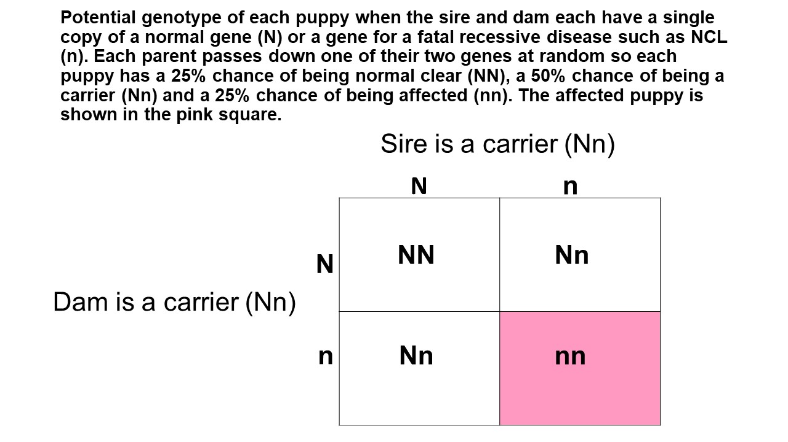
References
- Tsai KL, Vernau KM, Winger K, Zwueste DM, Sturges BK, et al. 2020. Congenital myasthenic syndrome in Golden Retrievers is associated with a novel COLQ mutation. J Vet Intern Med 34:258-65 https://onlinelibrary.wiley.com/doi/full/10.1111/jvim.15667
- Rinz CJ, Levine J, Minor KM, Humphries HD, Lara R, et al. 2014. A COLQ missense mutation in Labrador Retrievers having congenital myasthenic syndrome. PLoS One 9:e106425
- International Collaboration For Dog Health And Welfare. 2020. Harmonization of Genetic Testing for Dogs https://dogwellnet.com/ctp
- Moses L, Niemi S, Karlsson E. 2018. Pet genomics medicine runs wild. Nature 559:470-2 https://www.nature.com/articles/d41586-018-05771-0
- Shaffer LG, Sundin K, Geretschlaeger A, Segert J, Swinburne JE, et al. 2019. Standards and guidelines for canine clinical genetic testing laboratories. Hum Genet 138:493-9 https://link.springer.com/article/10.1007%2Fs00439-018-1954-4
- Baranowska I, Jaderlund KH, Nennesmo I, Holmqvist E, Heidrich N, et al. 2009. Sensory ataxic neuropathy in golden retriever dogs is caused by a deletion in the mitochondrial tRNATyr gene. PLoS Genet 5:e1000499 https://journals.plos.org/plosgenetics/article?id=10.1371/journal.pgen.1000499

