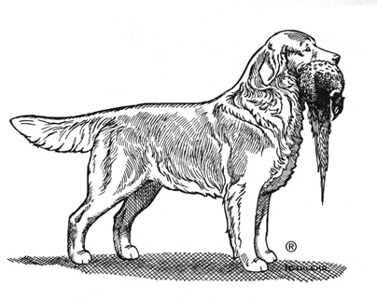
GRCA VC/VCX/VCM APPLICATION
(please print clearly)

Application for (circle one): Submit to: Karin Shinego
Versatility Certificate (VC) KarinShinegoGRCA@gmail.com
Versatility Certificate Excellent (VCX)
Versatility Certificate Master (VCM

Dog’s Registered Name
(registered name only – no titles)
AKC Registration # Birthdate
Owner(s)
Address
(Street Address)

(City) (State) (Zip Code)
Phone Email

Please circle the highest achievement earned in each column. The dog must have at least 1 point in each main Area (Area #1: Conformation Venue; Area #2: Obedience/Rally Venue and/or Agility Venue and/or Tracking/Scent Work Venue and Area #3: Field Venue) with a total of 12 points from all Areas for a VC, or a total of 20 points from all Areas for a VCX, or a total of 30 points from all Areas for a VCM. If the dog has multiple performance titles, the highest achievement in each Venue will be counted.

Schedule of AKC/GRCA Title Points for VC/VCX/VCM Award
 | Area #1 | Area #2 |  |  | Area #3
VENUES: | Conformation | Obedience / Rally | Agility | Tracking / Scent Work | Field
12 |  |  |  |  | FC or AFC
11 |  | OTCH | MACH | CT | ***
10 | GCH | UDX | PACH | VST or SWD | MH
9 | CH |  | MX or MXJ
8 |  | UD | MXP or MJP | TDX or SWM | **
7 |  | RACH | AX or AXJ |  | SH
6 |  | CDX | AXP or AJP
5 |  |  | OA or OAJ |  | WCX
4 | Major Points | CD or RM | OAP or OJP | TD or TDU | JH
3 |  |  | NA or NAJ | SWE | WC
2 | Minor Points | RAE | NAP or NJP
1 | CCA | RA or RE
VC POINT TOTAL ______ VCX POINT TOTAL _______ VCM POINT TOTAL _______
I hereby affirm that the above statements and the attached documentation are true to the best of my knowledge.

Signature of Applicant Date
(Effective January 1, 2023 – 22-78)

Submitting your VC or VCX Application
- You must be a current GRCA member.
- Applications need to meet the current Title-Point Schedule requirements
- You must complete the application form

Documentation
- For all AKC titles in order of preference
  - A link to the GRCA Yearbook page
  - A scan or photocopy of the most current AKC title certificate
  - A scan or photocopy of the dog’s official show or trial record provided by AKC
- For all GRCA titles in order of preference
  - A link to the GRCA Yearbook page
  - A scan or photocopy of the official CCA, WC or WCX title certificate
- For field trial placements or JAMs (three star or two star awards)
  - A link to the GRCA Yearbook page is required

The GRCA Yearbook page is the preferred documentation due to strict requirements for accuracy in the Yearbook Database. For access to the database go to: www.starzgoldens.com/yearbook and follow instructions.

VC/VCX/VCM certificates are not awarded until all titles have been verified.

We use the GRCA Yearbook Database for ownership and breeder verification as well. If ownership of your dog has changed you must also submit a scan or photocopy of the current registration.

VCX/VCM Write-ups and photos
VCX and VCM qualifiers will have a photo/write-up in the GRNews. Please submit a high resolution scan or photo and a write-up (maximum 150 words) with your application

